SHIVGADHI ENGLISH SCHOOL
Shivraj-1, Kapilvastu
1st Terminal Examination 2082
Class: Nursery F.M.
Subject: Math
Name: _________________________________________ Roll.No. ___________
Writing
Write 1 to 8
_______ _______ _______ _______ _______ _______ _______ _______

Reading
1 2 3 4 5 6 7 8
Speaking
How many fingers are there?
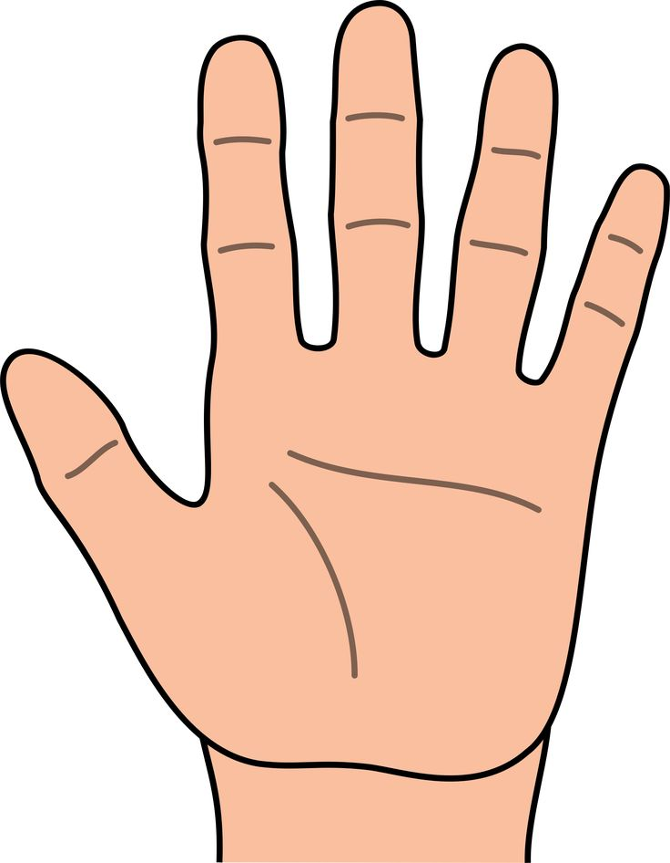

How many apples are there?




How many balls are there?


Listening
Pick up the pencil.
Show me your two fingers.
Please open the door.
Show me your nose.

THE END

